**BCI-Study summary report**

**Reporter: Baishan Zhou**

**Catalog**

Project background and principle ·································P2

Project content···················································P3

Practice based on Theory·········································P10

experimental result··············································P13

Project summary···················································P16

1、 Project background and principle

Brain computer interface (BCI) is a collection of technologies that measure the activities of the central nervous system and transform them into artificial outputs that can replace, restore, enhance, supplement or improve the natural output of the central nervous system, so as to change the central nervous system and its external or internal environment.

Brain computer interface is generally combined with the following research directions: biomedicine, instrument design, signal processing, machine learning.

Biomedicine is mainly involved in the study of brain working mode. The brain relies on large-scale neuronal discharge to transmit electrical stimulation signals, and brain computer interface mainly collects the internal information of the brain through the study of event-related potential and oscillation process.

The instrument design is mainly based on electromagnetic, infrared radiation, nuclear magnetic resonance and other ways to design different sensors to monitor the electrical activities in the brain. The main instruments are: muse, openbci, EEG cap, etc.

Signal processing is the process of analyzing and processing the data collected by the instrument and extracting useful information. It mainly collects and filters EMG signal, eye movement signal, action potential and SSVEP signal. PCA, ICA, LDA and other methods are used to analyze the main information of the signal, and different means, such as PSDA, CCA, machine learning and other methods are used to classify the signal, and finally extract the useful information.

Machine learning mainly studies how to extract and classify the original EEG signals by means of feature extraction and translation algorithm. There are PCA principal component analysis, ICA independent component analysis, LDA hidden component analysis for signal extraction, SVM support vector machine classification, machine learning method classification, K-means clustering and other methods to classify different EEG signals.

2、 Project content

(1). **signal processing**

**a**. Signal classification in signal processing: analog signal, digital signal. Analog signal: analog signal refers to the change of signal waveform simulating the change of information. Its main feature is that the amplitude is continuous, and it can take unlimited values; while in time, it can be continuous or discontinuous. The computer can't process the analog signal directly, it needs to carry on the analog-to-digital conversion (ADC). Digital signal is not only discrete in time, but also discrete in amplitude, so it can only take a finite number of values. Analog to digital conversion includes five steps: sampling, holding, quantization and coding.

**b**. Important concepts in signal processing: convolution, Fourier transform, digital filter, sampling theorem, time domain analysis, frequency domain analysis, wavelet transform, etc.

Convolution: simple definition: it is an important operation in analytical mathematics. Let f (T) and G (T) be two integrable functions on R1. Convolution is to integrate f (T) and G (t-t0) in the whole time domain.

Fourier transform (DFT): from the knowledge of Fourier series, we know that all functions satisfying the Dirichlet condition have Fourier transform, that is, all functions can be expressed as the superposition of a group of sine functions. Therefore, we can have different expressions for the same signal: time domain: the relationship between signal amplitude and time, that is, the function of amplitude with respect to time; frequency domain: the relationship between signal amplitude and frequency, that is, the function of amplitude with respect to frequency.

There is a fast algorithm for Fourier transform, called fast Fourier transform (FFT). The idea of FFT is to decompose the DFT of large points into DFT of small points by using the symmetry of discrete Fourier transform.

Fourier transform introduces several important functions: impulse function, step function, sampling function, gate function, SA function and so on. Among them, the Fourier transform of SA function is a gate function, which is an ideal low-pass filter. We can do ideal low-pass filtering for some signals.

Digital filter: definition: it is a kind of signal processing system, which can retain useful signal components and filter out none

The output signal can meet the design requirements. Features: the processing can be carried out in the transform domain (usually in the frequency domain) or directly in the original domain (such as the time domain) of the signal. Band classification: low pass filter, high pass filter, band pass filter, band stop filter. According to the time width (column length) of unit impulse response H (n), digital filters are divided into IIR (infinite impulse response) infinite impulse response filter, recursive (with feedback) implementation structure, fir (finite impulse response) finite impulse response filter and non recursive implementation structure. The recursive characteristic of IIR ensures the lower order of the filter, and the filter with narrow transition band can be obtained, but it will cause the problem of nonlinear phase. Fir has strict linear phase characteristics, and its poles are all at the origin, which ensures the stability of the system, meets the causality, and has small operation error. A series of advantages make fir widely used in computer filter design. Users can build the filter manually on MATLAB, or design the filter parameters directly with the help of FDATool or filter designer command.

Sampling theorem: assuming that the sampling frequency is f, if the maximum frequency of the signal exceeds f / 2, then in the ideal sampling spectrum, each modulation spectrum will overlap with each other, resulting in spectrum "confusion". When spectrum confusion occurs, it is generally impossible to filter out baseband spectrum without distortion, and the signal recovered by baseband filtering will be distorted. In practical work, considering the noise, in order to avoid spectrum aliasing, the sampling frequency is always larger than the maximum frequency of twice the signal, generally 3 ~ 5 times.

In order to avoid the interference of out of band noise, the sampler usually adds a protective pre band-pass filter, which can not only filter out the out of band noise, but also let the signal pass through.

Time domain analysis: definition: filtering, amplification, statistical characteristic calculation, correlation analysis and other processing of signals in time domain, collectively referred to as time domain analysis of signals. Representation: difference equation (zero input response, zero state response, full response). Advantages: intuitive and accurate, disadvantages: complex calculation, difficult frequency analysis.

Frequency domain analysis: the way to find out the information (amplitude, power, intensity or phase, etc.) of a signal at different frequencies is spectrum analysis. Advantages: the most widely used, simple and effective description of signal characteristics, disadvantages: no time resolution.

Wavelet transform: a method to overcome the shortcomings of short time Fourier transform and Gibbs phenomenon wavelet transform

The multi-scale thinning of the signal is realized by stretching and shifting the base vector: time subdivision at high frequency, frequency subdivision at low frequency, self-adaptive, and can focus on any detail of the signal

(2) **PCA principal component analysis**

**a.** Background

In the analysis of data in many disciplines, it is often necessary to analyze the data with multiple variables. However, after collecting a large number of data to analyze and find the law, it will undoubtedly provide rich information for research and application, but in many cases, there are correlations between many variables, which makes the workload of data analysis greatly increased. So we need to find a way to extract the main part of the information as far as possible, filter out the secondary information or useless information, in order to achieve the purpose of a more comprehensive analysis of the collected data. Because there is a certain correlation between the variables, we can consider changing the closely related variables into as few new variables as possible, and making these new variables orthogonal to each other, so as to extract the information as much as possible.

**b**. Principal component analysis (dimension reduction)

Dimension reduction is a preprocessing method for high-dimensional feature data, which can preserve the most important features of high-dimensional data and remove the unimportant features, so as to improve the efficiency of data processing. In the actual production and application, dimension reduction in a certain range of information loss, can save us a lot of time and cost, and filter the noise to a certain extent. Dimension reduction has also become a widely used data preprocessing method.

**c**. Basic principles

When the target to be analyzed is m data X in an n-dimensional space_ (n*m)=[x1,x2,…… The goal is to find an n * n-dimensional transformation matrix w such that y = [Y1, Y2,...] , YM] = w'x, the correlation between the dimensions is the minimum, that is, the original information is retained to the maximum extent, so as to achieve the purpose of decorrelation.

How to measure the correlation between two variables? Covariance is defined here: the mathematical expectation of the product of the deviations of two random variables is called the covariance of the two variables, which is recorded as cov (m, n). Random vector x = (x1, X2,...) The covariance matrix C is composed of the covariance between the elements of (xn), that is, C (I, J) = cov (Xi, XJ). There is a transformation w satisfying WCW '= a (a is a diagonal matrix, the elements on the diagonal are eigenvalues and W is eigenvector). Then the transformation y = w'x can make the covariance between different elements of y equal to 0. The size of the eigenvalues corresponds to the importance of the corresponding eigenvectors, so removing the eigenvectors corresponding to the smaller eigenvalues from w will reduce the dimension with the least information loss. The first k main components of the original data are extracted by selecting the matrix composed of the eigenvectors corresponding to the first k large eigenvalues. As shown in the figure below:

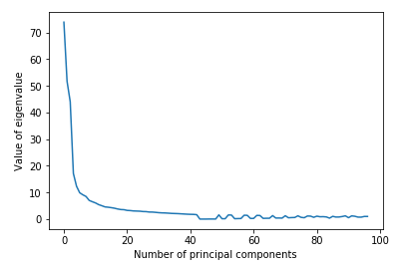

(3). **SVM support vector machine**

It analyzes the linear separable case. For the linear non separable case, it uses the nonlinear mapping algorithm to transform the linear non separable samples in the low dimensional input space into the high-dimensional feature space to make them linear separable, so that it is possible to use the linear algorithm to analyze the nonlinear features of the samples in the high-dimensional feature space.

Based on the theory of structural risk minimization, it constructs the optimal hyperplane in the feature space, which makes the learner get global optimization, and the expectation in the whole sample space satisfies a certain upper bound with a certain probability.

(4). **Other machine learning models**

Supervised learning: linear regression, KNN, SVM, some neural networks

Unsupervised learning: clustering, PCA, self organizing neural network

(5). **EEG signal analysis algorithm used**

**a**. PSDA

The N observation data of random sequence x (n) are regarded as a sequence with limited energy. The discrete Fourier transform of X (n) is calculated directly to obtain x (k), and then the square of its amplitude is taken and divided by n to estimate the real power spectrum of the sequence x (n). In MATLAB, EEG can be transformed by fast Fourier transform, and then the power of different frequency bands can be calculated according to the amplitude of different frequencies and the length of signal coverage, so as to achieve the purpose of power spectrum classification.

**b**. CCA

To study two groups of variables: http://latex.codecogs.com/gif.latex?%20\%5b%7bX_1%7d,%7bX_2%7d,...,%7bX_n%7d\%5d%25%20MathType!End!2!1! and http://latex.codecogs.com/gif.latex?%20\%5b%7bX_1%7d,%7bX_2%7d,...,%7bX_m%7d\%5d%25%20MathType!End!2!1!，List a table, just like studying the covariance matrix, which contains the correlation between any two variables of two groups of variables. Then, the analysis is based on the correlation coefficient table. In MATLAB, the canoncorr function is used for correlation analysis. The canoncorr function returns the correlation coefficient between the data. By comparing the size of the correlation coefficient, we can classify the signal.

(6). **Control methods used**

**a**. SSVEP steady state visual evoked potential

SSVEP refers to that when people are stimulated by a fixed frequency of visual stimulation, the visual cortex of human brain will produce a continuous response related to the stimulation frequency (at the fundamental frequency or frequency doubling of the stimulation frequency). The subjects can send out EEG signals by watching visual stimuli flashing at different frequencies to control the corresponding devices.

**b**. Motor imagery control: by imagining the movement of the object or the subject's body to generate the corresponding EEG signal, so as to control the corresponding equipment.

**c**. Through the acquisition of eye electrical signal, EMG signal to control.

**d**. By monitoring the physiological awake state to control the corresponding equipment.

7. **Actual operation**

In this project, it is required to realize the above algorithm, realize brain computer connection, and analyze the signals in EEG. The general idea is as follows:

**a**. Generation of EEG signal

The above four methods, including SSVEP, motor imagery control, eye electricity, EMG signal control and awake state analysis, are introduced to generate the required EEG signals.

**b**. Acquisition of original EEG

In this project, the laboratory provides two kinds of EEG acquisition equipment, one is 4-channel muse, the other is 64 channel EEG cap. Among them, Muse is mainly used to monitor people's waking state, and EEG cap has more comprehensive functions, which can match all the above algorithms.

**c**. Signal processing

The EEG signal collected by muse and EEG cap is an original analog signal without any processing. We must try to do some necessary preprocessing for this signal, such as analog-to-digital conversion, FFT, filtering, etc.

**d**. Signal analysis

Several signal analysis methods are introduced in theory class, including PCA, ICA, PSDA, CCA, SVM, neural network, etc. We can use these methods to do some basic classification of signals.

**e**. According to the results of signal analysis, the corresponding devices are controlled to realize brain computer interaction.

3、 Practice based on Theory

According to the above ideas, this group has written a simple program, through the SSVEP control, to achieve the use of EEG signals to play a small game - 2048. Corresponding to the above framework, the specific implementation ideas are as follows:

**a**. In the aspect of signal generation, we choose SSVEP, and exclude the other three kinds of EEG signal generation methods. The reasons are as follows: firstly, motor imagination control needs long-term training for the subjects; secondly, motor imagination control involves complex multi classification tasks, so the requirement of building a multi classifier based on machine learning is beyond the ability of the team members; the functions of eye electricity and electromyography signal are relatively single, which cannot be excluded; the analysis of awake state is not suitable for the needs of the group. Because the concept of SSVEP is clear, the design of paradigm is relatively simple, and there are many applications that can be realized, our group finally chose SSVEP.

In the aspect of paradigm design, we use the psychotoolbox package on MATLAB to generate stroboscopic and design stimulus paradigm. We stipulate that 6.7hz is up, 10Hz is down, 12Hz is left, 15Hz is right and 20Hz is exit. As shown in the figure below:



**b**. In the part of signal acquisition, we choose the more powerful 64 channel EEG cap.

**c**. In the signal processing part, we plan to carry out band-pass filtering and FFT on the received original EEG signals.

Considering the frequency band of visual stimulus paradigm, we design a band-pass FIR filter with 4-20hz. The filtered signal is transformed by fast Fourier transform. The following is the filter and FFT code

while true

sound(sin(0.1*pi*(1:1000)));

pause(6);

data = dataClient.GetBufferData; % Get data from buffer

% save('data1.mat','data');

a=data(1:8,:);

for i=1:8

a(i,:)=filter1(fs,a(i,:),4,20);%调用设计好的filter1函数对信号进行滤波

end

Y1=0;Y2=0;Y3=0;Y4=0;Y5=0;

N=length(a);

for channel=1:8%八通道分析

Temdata=a(channel,:);

ff=fft(Temdata);%对信号做快速傅里叶变换

**d**. In the aspect of signal analysis, we first considered SVM, hoping to make a basic classification of EEG signals with the help of SVM. But after consulting the teacher, we learned that the performance of SVM in dealing with multi classification task is not excellent. At last, we choose PSDA algorithm from PSDA and CCA algorithm which are close to EEG analysis. This is because PSDA can better adapt to the noisy experimental environment because of all kinds of interference in the experimental acquisition environment. The following is the power spectrum analysis code:

for channel=1:8

Temdata=a(channel,:);

ff=fft(Temdata);

p= (abs(ff));

p=p/(N/2);

p(1,1)=p(1,1)/2;

p(1,:)=p(1,:).^2/N;

X1=round(6.67*N/fs+1);

X2=round(10*N/fs+1);

X3=round(12*N/fs+1);

X4=round(15*N/fs+1);

X5=round(20*N/fs+1);%20Hz为退出游戏

Y1=Y1+p(1,X1);

Y2=Y2+p(1,X2);

Y3=Y3+p(1,X3);

Y4=Y4+p(1,X4);

Y5=Y5+p(1,X5);

end

if (Y1>Y2)&&(Y1>Y3)&&(Y1>Y4)&&(Y1>Y5)

way='w'%fwrite(way,'w','char');%向上

elseif (Y2>Y1)&&(Y2>Y3)&&(Y2>Y4)&&(Y2>Y5)

way='s'%fwrite(way,'s','char');%向下

elseif (Y3>Y1)&&(Y3>Y2)&&(Y3>Y4)&&(Y3>Y5)

way='a'%fwrite(way,'a','char');%向左

elseif (Y4>Y1)&&(Y4>Y3)&&(Y4>Y2)&&(Y4>Y5)

way='d'%fwrite(way,'d','char');%向右

elseif(Y5>Y1)&&(Y5>Y2)&&(Y5>Y3)&&(Y5>Y4)

return;%退出游戏

end

**e**. We hope to achieve some simple small functions through brain computer connection. Game 2048 well meets our needs. This game has several characteristics to meet this experiment

The real-time performance is weak. Considering that the interface of visual stimulation paradigm is not easy to combine with the game interface, two computers must be used to realize it, one is to play visual stimulation, the other is to display the game, so the game based on SSVEP must not have strong real-time performance. 2048 can meet this requirement well. Players can observe the game interface first, think of the next operation, and then watch the stimulation paradigm.

(2) The operation is simple. Players who have played 2048 all know that the operation of this game is very simple, just need to control all the blocks to move up, down, left and right. This provides convenience for the design of stimulus paradigm.

(3) The design of the game and the construction of GUI are relatively simple. As we all know, 2048 is a mobile phone game. If we want to control 2048 with visual stimulation, we should first write a 2048 game in MATLAB, and it is better to make a GUI. The implementation principle of 2048 and the design of GUI are easy to complete. The game and GUI are as follows:

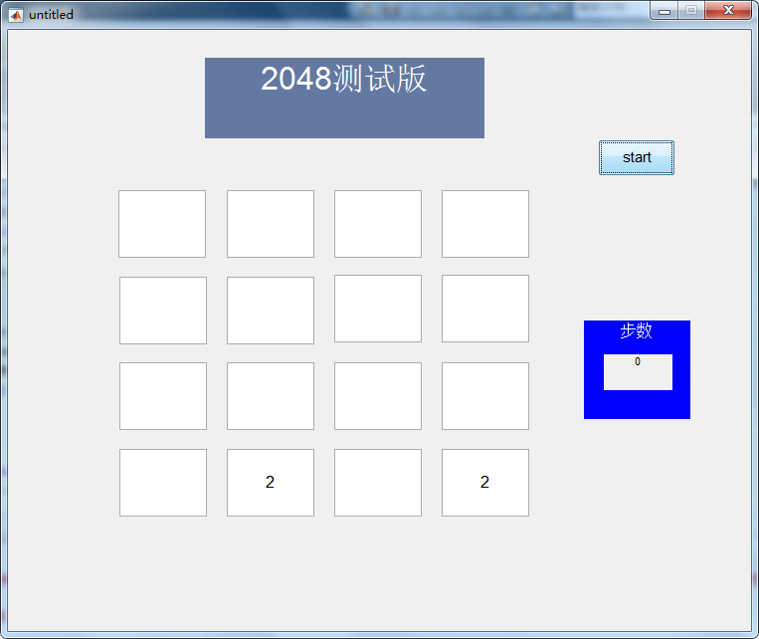

4、 Experimental results

1.

First of all, we have built a complete set of programs, but we can't verify the function of our program without actually connecting the EEG cap. So before the formal demonstration, we used a group of offline EEG data provided by teachers to debug our program.load('E:\BCI\数据\LED_four_red_6.7Hz1.mat')%读取数据

However, there is no 20Hz component in the EEG data provided by the teacher, so the program can only be stopped manually.

2.

After debugging the program, we changed the code of the data receiving part to receive data through WiFi, and connected the EEG cap for debugging. At the beginning, there were some bugs in the code of the data receiving part. After debugging, the program ran normally. As can be seen from the figure below, the program ran smoothly and successfully realized brain computer interaction.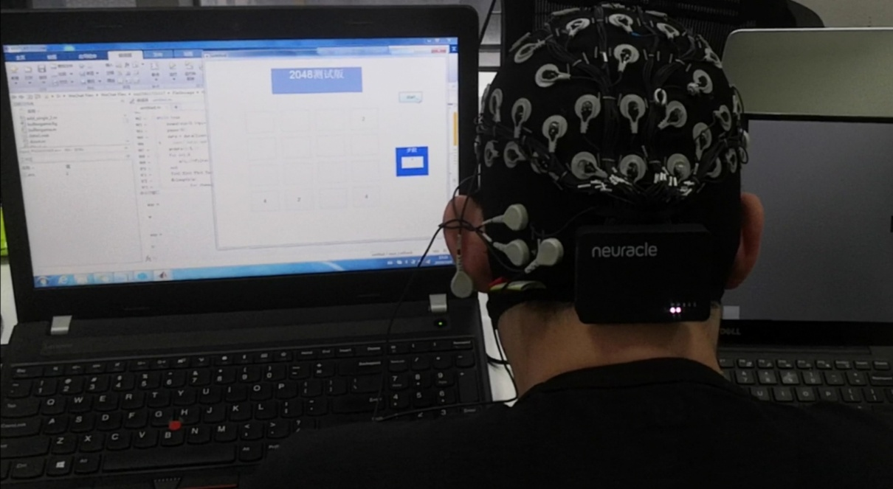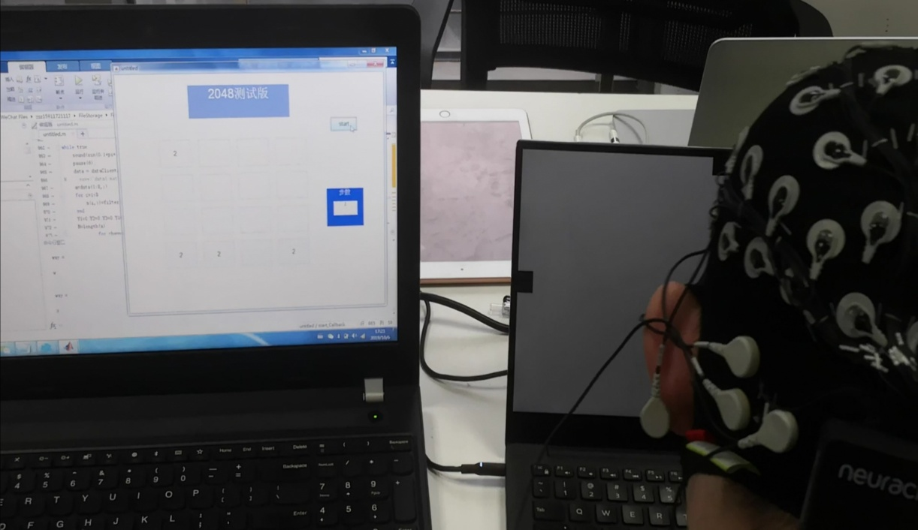

*(the computer on the left displays the game interface, and the computer on the right displays visual stimulation)*

3. **Possible improvements and other options**

**a**. This visual stimulation paradigm can be improved. According to the teacher, the exit frequency of 20Hz in our visual stimulation paradigm is not properly designed. This is because our paradigm already has a frequency of 10Hz, and 20Hz is an integral multiple of 10Hz, so it is easy to interfere with each other in power spectrum analysis. You can modify the exit frequency, for example, to 18Hz.

**b**. The design of the filter is defective. The teacher pointed out that the passband of the filter must have a certain margin. Since we have designed the exit frequency of 20Hz, the upper limit frequency of the filter should not only be 20Hz, but should leave a certain margin.

**c**. The visual stimulation paradigm can be combined with the games we play. The teacher pointed out that the psychotolbox package has an interface for inserting numbers. This also means that we don't need to run the game and display GUI on another computer, but can display GUI as a picture on the background of visual stimulation, and insert several numbers in 2048 into the top of the background picture to realize the unification of visual stimulation and game interface. As shown in the figure below: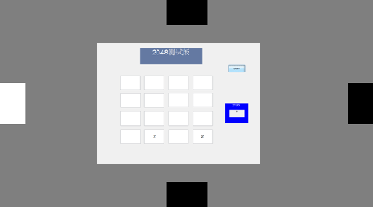

**d**. In this project, there are many algorithms and stimulation methods that we haven't tried. In the next study, we can try to use different algorithms to realize our functions, so that we can compare the performance of different algorithms and understand the application scope of different algorithms.

Try to do a simple control with the help of EMG signal and SVM binary classification.

Try a variety of signal processing methods, such as wavelet transform, Laplace transform, z transform. I guess that wavelet transform should be able to retain the information of time domain and frequency domain at the same time, but the amount of calculation is large; the performance of Laplace transform should be similar to that of Fourier transform.

We can try to use PCA, even deep learning algorithm to do a multi classification of visual stimuli, so that we can achieve more complex functions.

It can compare the advantages and disadvantages of CCA and PSDA as well as the anti-jamming ability.

You can try different stimulus frequencies to see which frequencies humans are most sensitive to.

5、 Project summary

1. **Learned knowledge**

Through reading the preview materials given by the teacher, I understand the concepts of training model, over fitting, precision and recall, generalization error, supervised learning and unsupervised learning, and the concepts of neural network, perceptron, deep learning, SVM, k-nearest neighbor learning, principal component analysis, etc.

Before I participated in this project, I was unfamiliar with the concept of brain computer interface. First of all, I understand the overall concept of BCI, the subdivision of research direction, the strategic importance of research, and the general research direction in the future.

Understand a lot of algorithms used in BCI, some algorithms such as FFT, PSDA, PCA understand more thoroughly, also carried out the corresponding attempt and application. Understand the principle and application scope of CCA, SVM, CNN, K-means and other algorithms.

2. **Master the technology**

In this project, we have actually operated PCA algorithm in Python, understood the principle and application method of PCA algorithm, and mastered the method of dimensionality reduction of high-dimensional data with PCA.

This project also tried K-means clustering, and I initially mastered the usage of K-means clustering algorithm.

In this project, we use visual stimulation to control the game. Now I will use matlab to build digital filter, write PSDA algorithm, Fourier transform the signal, and design visual stimulation paradigm with psychotoolbox.

3. **Other gains**

In this project, through the communication and learning with my classmates, I learned new knowledge, new ways of thinking, realized my own shortcomings, and made some friends.

Expand my horizons. Usually in school to learn theoretical knowledge, there are not many opportunities to contact with the most cutting-edge technology, this project is a good opportunity for me, let me see more, learn more.

My ability to solve problems has been developed. In the practice of this project, our group encountered a lot of problems, whether it is to correct the deviation of concept understanding, or debug the code, all require me to be able to find and solve problems, this process has well cultivated my ability to solve problems.

Learn more about learning ways from teachers. In the past, when I wanted to understand a concept and try a technology, I always felt that I couldn't start. Now I know GitHub, courcera and other websites, which are very suitable for my learning platform.